Cecilia Kurkowski
Job Shadow Experience
12-13-2019
Kentucky Horse Park: Mounted Police
Captain Lisa Rakes is the captain of the mounted police unit at the Kentucky horse park. She grew up on a farm and has always been around horses. She bought her house with acreage with the intentions of having personal horses but did not plan on working with them in her career. She now has two ponies and some retired horses as companions at home rather than riding horses because her kids are more into basketball and she does not have much time to ride them. She enjoys being outside as much as possible and knew she could not have a typical office job. After the police academy, she worked with the Lexington police and it was then that she got involved with the mounted unit. While in the city unit, they always had to wear bullet-proof vests as they were involved with crime heavy areas. Captain Rakes then retired to the mounted unit in 2013. Patrolling the park is much different and not as enjoyable as in the city, but she says neither one was better as they are so different. Her hours vary the most as she oversees everything and everyone related to the officers and police horses at the park and it is not unusual for them to work 15 hour days. She is in charge of all the paperwork and logging which is her least favorite part about the job. There are about 10 officers in her unit, but not all of them ride. There are 7 police horses currently as they recently retired one of them. She wants to have more horses there, but her boss makes those calls. Her horses in the unit are Oliver, the recent Breyer horse of the year, and Henry, one of the three 4-year-olds they had since weanlings. She says that it is required to be an officer at least two years prior to joining a special force, but she says she honestly prefers officers to have about five years of experience because it is so different and you still have to do normal police work as well as extra things as there are horses involved. Captain Rakes also coordinates lessons with a few different skilled trainers of other disciplines. The lessons focus on horsemanship and equitation. The Lexington mounted unit and the Georgetown mounted unit sometimes join their lessons. The lessons are hard to fit in with their busy schedules and are typically once a week in the winter, but very rare in the summer. Captain does, however, encourage everyone to ride whenever they can to keep up on skills and mutual respect with their horse.
Trooper Roy Foster is a member of the unit and is from Flint Michigan. He was an officer primarily on motorcycles when he was offered to be in the mounted unit in Detroit. He had never been on a horse before and experienced his first time riding bareback when he went to go train for the mounted unit. He had a horse of his own and was on his way down to Florida for work. As he had to trailer his horse, he made a stop in Kentucky, and he ended up never leaving. He now rides Turk, a 10-year-old drum horse. The best things Roy says about his job is the horses, but his least favorite is that he does not get much time to ride. He works whenever he is put on the schedule, usually very early mornings to early afternoon.
Angel is the barn manager for the mounted police barn. She had previously worked at the breeds barn within the park, which is where most of her experience and qualifications came from. She said she had been riding for about 14 now and grew up with them. Although she has no police background, she gets to ride with the officers on patrol around the park. She works 5 days a week, typically from 8 to 4:30 unless something else is going on because she is only supposed to work 8-hour shifts with a 30-minute lunch break, and two 15-minute breaks. As it is a state job and work all year, she gets full benefits with her pay of $11/hour. She says that the seasonal workers at the park only make $10 without benefits. Angel rides Parker who she calls “wee,” another one of the three 4-year old’s they received. She says that experience is what you need for the job. Being flexible and understanding of your horse because they do not care if the horse is afraid, they are looking for their willingness to continue and your strength as an individual to get them there.
I also learned a lot about the routine and care of the horses themselves. All of them are ridden in official police gear which includes a Steuben English saddle. Henry has an official western saddle that Captain sometimes rides him in as he is young and can be wiggly. They have nice new nylon halters, but they usually are handled with a rope halter as Captain is big on horsemanship and believes it should not take much force for the horse to respond. They are groomed daily, and usually by their rider as they are usually only brought in if their officer is their that day. They are also occasionally bathed especially before events. They get their horses from donations but most of them are on a long-term lease. The horses are turned out at night and brought in in the morning just after 8 am. While inside, they are fed a flake of hay every two hours. They get one pound of grain along with their supplements before they are turned out for the night. All of them receive a joint supplement and some get biotin for their hooves as well.
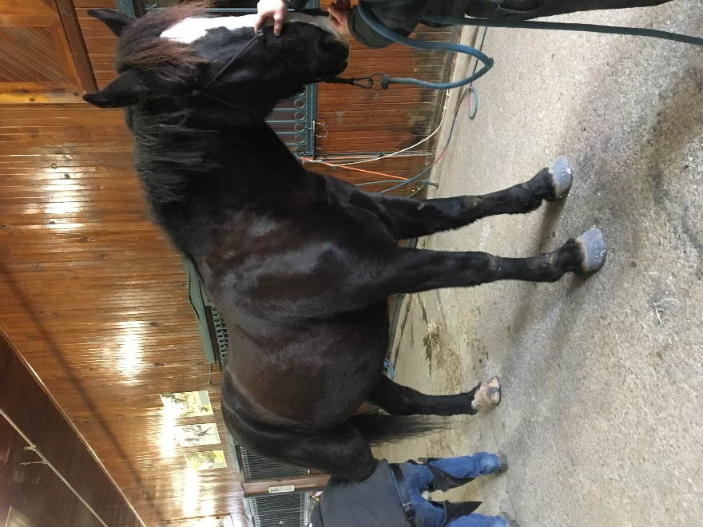
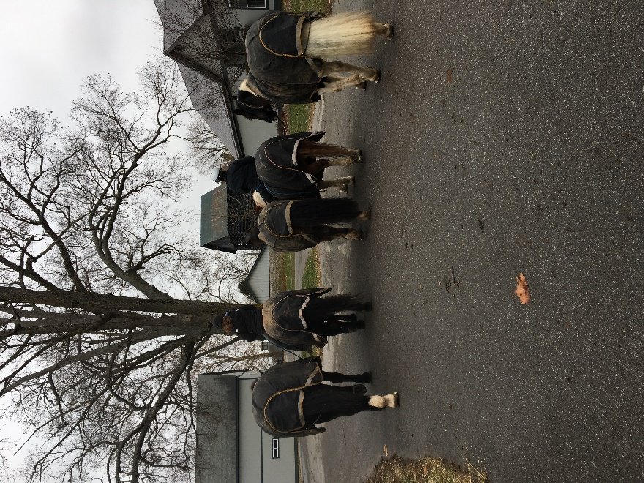
This was probably the coolest shadow ever. I learned so much about their care for horses and multiple jobs. I got there about 9 in the morning, met Captain, Angel, and Roy. I started my shadow with Roy, helping him set up cones and road blocking signs for the light parade. I then spent most of my time with Angel after that. Their farrier, Tony Rankin, was there and it was not an eventful day, but that was good for me because I got a lot if time to ask questions without interrupting anything. In between the horses, I helped feed and Angel gave me a tour. After the farrier, I got to go in and talk to Captain as she was finishing up some paperwork. Later, I helped Angel grain the horses and went out to hay the field. Captain and Angel took the horses out to their field, and when they got back, I helped Angel pick the stalls, dump water buckets, and throw hay for the morning. (Pictured Below; Left: Koda getting his back shoes for the first time, Right: Captain Rakes and Angel riding horses out tackless in rope halters for turnout).
The biggest take-away was probably gaining insight about their personal lives with horses and their main life decisions reiterated the fact that not everything will go as planned, and you have to be open to new opportunities. The most interesting thing to me was that there was not as much riding as I thought there would be nor the amount that they hope for. I also thought it was awesome how much they ride bareback and trust the horses to not act up on their way through the park to their field. It was refreshing to see how well these horses were taken care of and understand how willing they are to approach something that they fear. I also found out that the horses used for the riding test are typically Mac or Turk, which I think is just cool because if I do decide to take my internship with them, I know the horses. I did not think of it before, but as a park, it is patrolled 24/7 and there is at least one officer there at any given time, including holidays. Personally, after experiencing this career path rather than just researching it, I do think it is a decent fit for me. I am very interested in public services, but not as invested as I should be to gain enough experience for the job. I think it would be beneficial for me to shadow the Lexington mounted unit as well as their regular officers if possible, to get another foot in the door. Captain Rakes seemed fairly happy to hear that I was a rider as most of those that enter the mounted units do not ride. I can see this career being a possibility especially after Trooper Roy said “you’re definitely in.” I also had a great experience seeing the role of a barn manager that also has the perks of riding police horses and patrolling without the government training or city experience. I always saw myself having my own barn or at least managing someone else’s so it was neat to be able to see how their routine was different from others I have seen. I think that I need more official experience overall especially because I am not yet certain even though I am very interested in this career path.

